INTRODUTION
OVERVIEW
- Our team’s alloted project is certificate debate We all work togetherand designed this project
PURPOSE
- We designed this project to promote our/my certificate to the student

PROBLEM DEFINITION & DESIGN THINKING
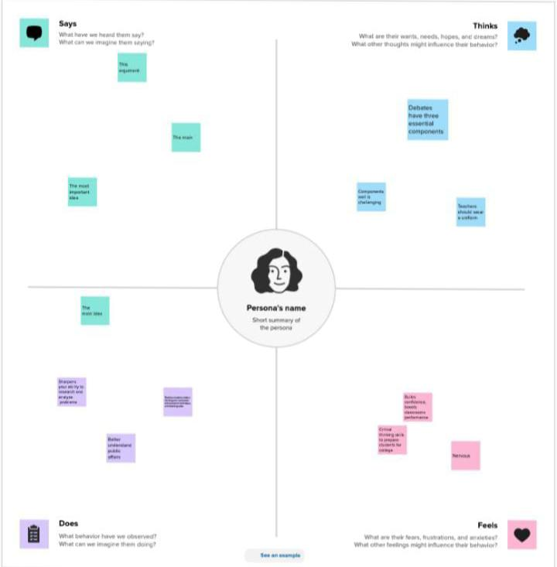
EMPATHY MAP:

BRAIN STROM :
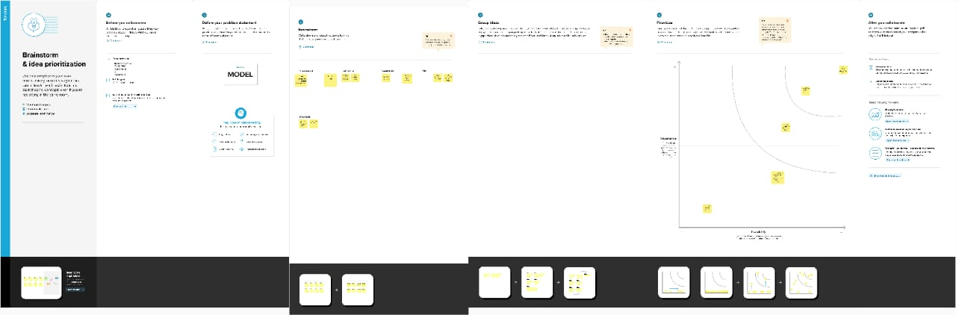

RESULT
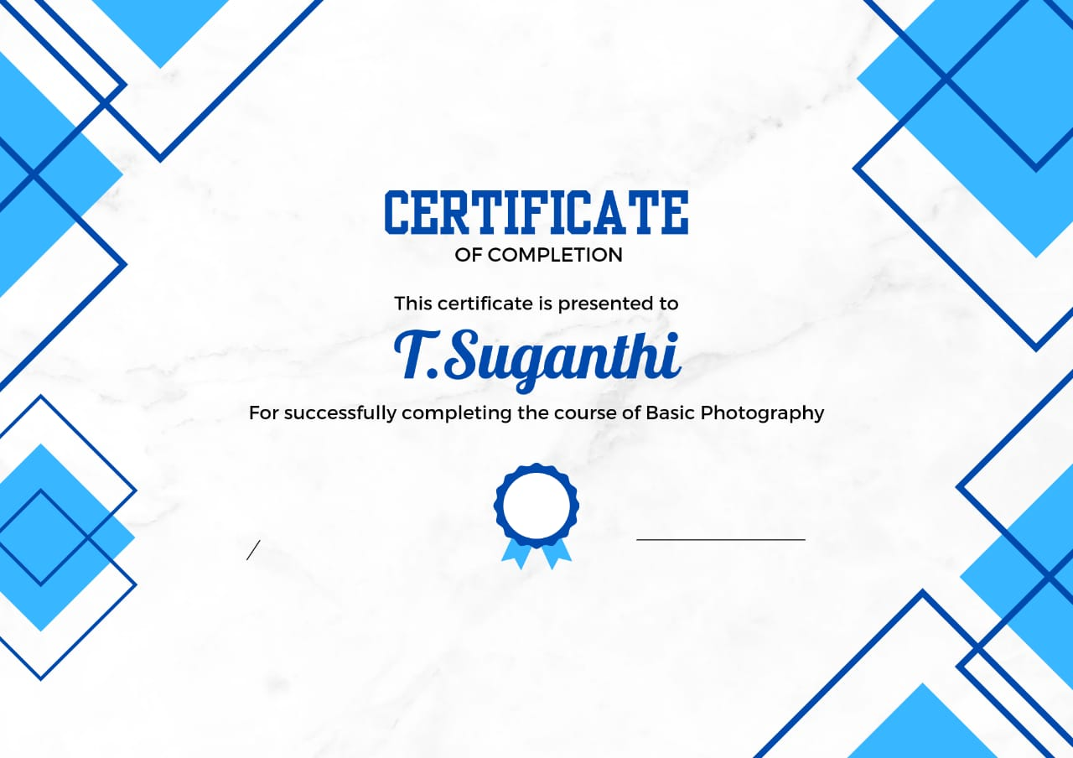

ADVANTAGES & DISADVANTAGE
- Our certificate can reach the people easily this can improve our certificate
- Iliterate may not understand

APPLICATION:
It have develop my certificate

CONCLUSION:
With help of canva app we have design our project successful

